- 学年小结 Summary of Academic Year
  - 浏览器中输入 https://intlstudent.zju.edu.cn/isstu，点击统一身份认证登录系统（建议使用谷歌浏览器）
Enter https://intlstudent.zju.edu.cn/isstu in your browser and click the Unified Identity Authentication to log in to the system (Google Chrome is recommended).
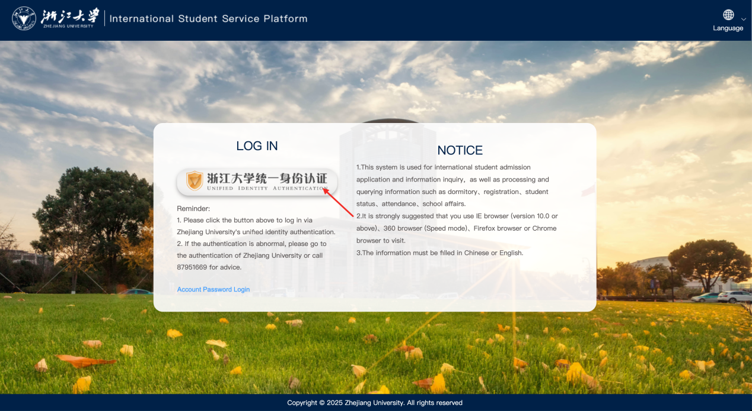
  - 进入系统后点击“学年小结”
After logging into the system, click on “Summary of Academic Year”.
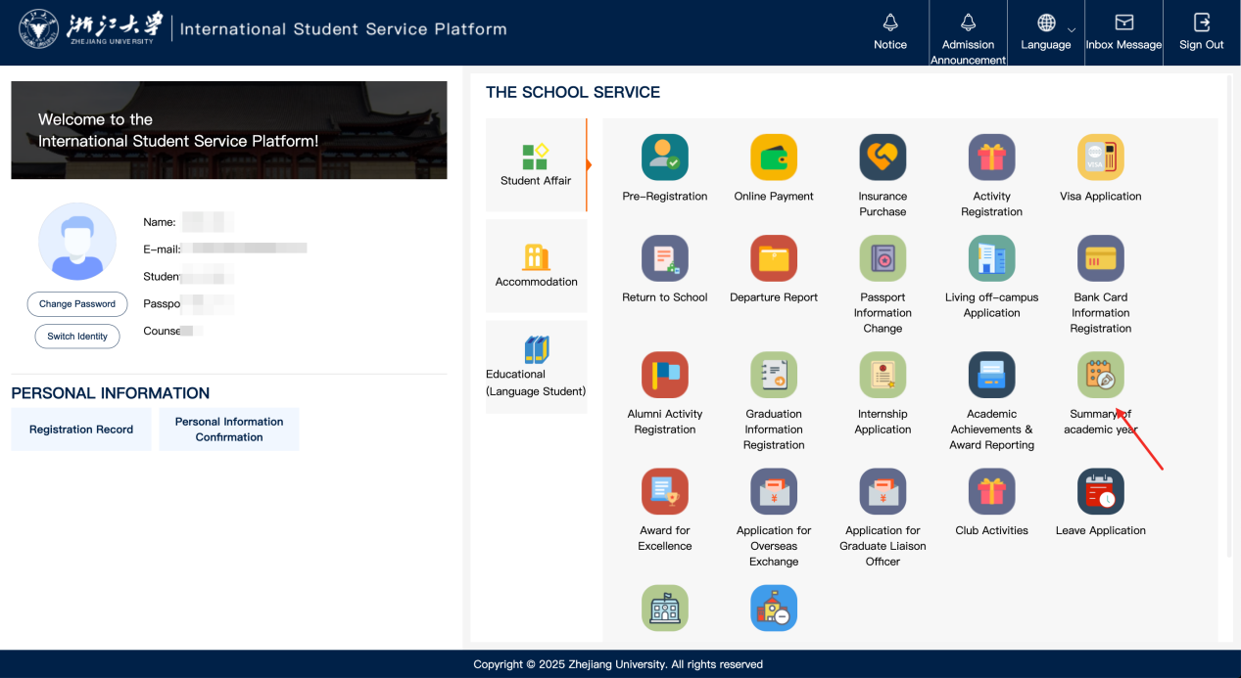
  - 根据页面提示确认个人信息并填写相关内容，点击“保存草稿”后，点击“下载学年小结表”，签字盖章后将学年小结表上传，点击提交，即可完成。
Follow the on-screen prompts to check your personal information, and complete the relevant sections. After clicking “Save Draft,” click “Download Academic Year Summary Form”. After signing and stamping, upload the form. Click “Submit” to complete the process.
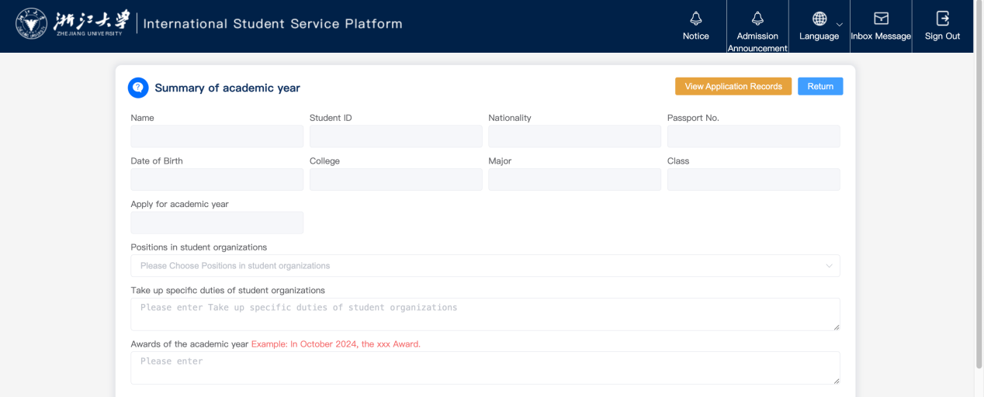
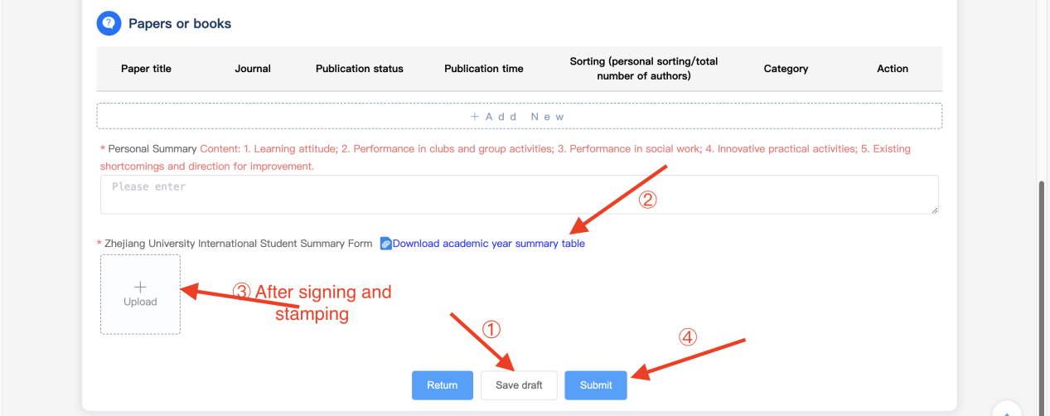
  - 查看上传记录：点击【查看上传记录】，即可查看
View Upload Record: Click on "View Upload Record" to view the records.
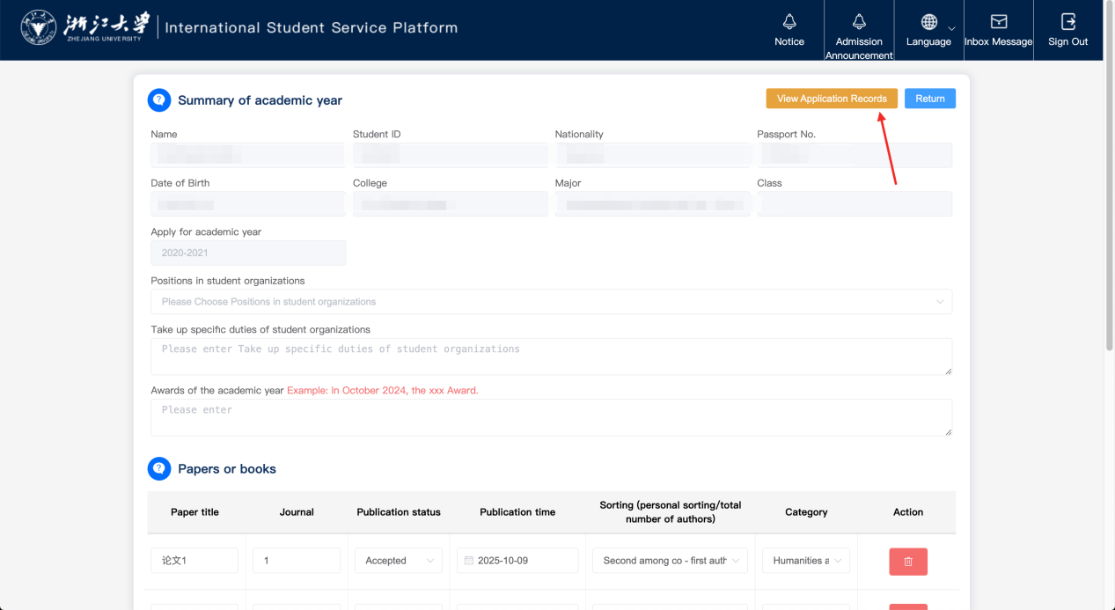
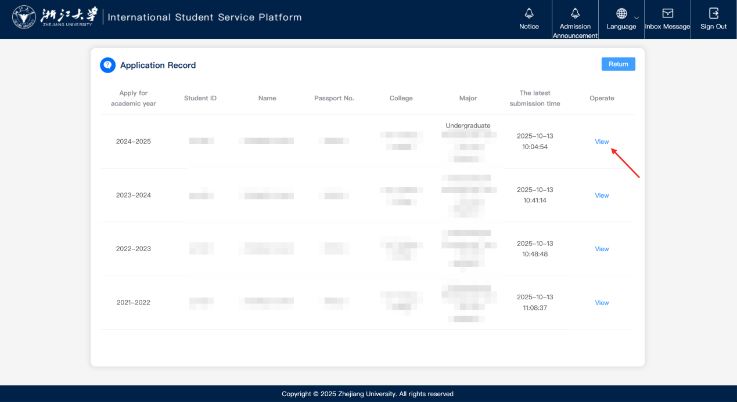

二、荣誉称号申请 Awarding Honorary Titles to International Students
  - 浏览器中输入 https://intlstudent.zju.edu.cn/isstu，点击统一身份认证登录系统（建议使用谷歌浏览器）
Enter https://intlstudent.zju.edu.cn/isstu in your browser and click the Unified Identity Authentication to log in to the system (Google Chrome is recommended).
  - 进入系统后点击“评奖评优”
After entering the system, click on "Award for Excellence".
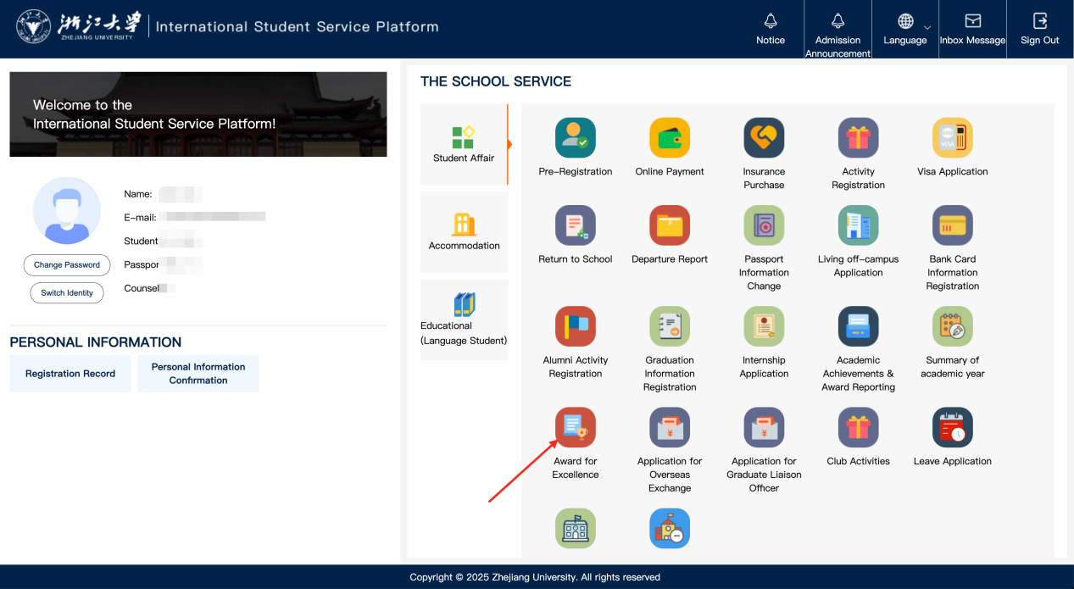
  - 选择“国际学生荣誉称号”
Click “Awarding Honorary Titles to International Students”
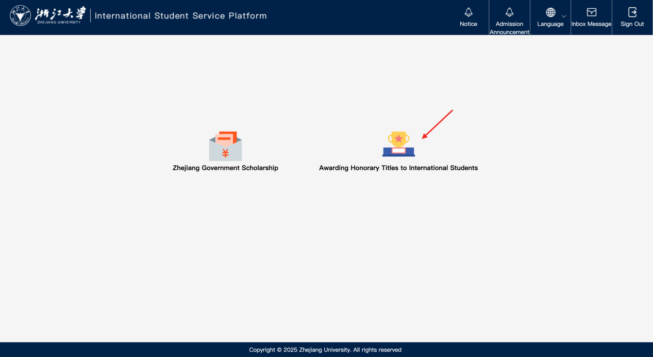
  - 根据页面提示确认个人信息、阅读申请须知并填写申请信息，点击“保存草稿”后，点击“申请表下载”，签字盖章后将申请表上传，点击提交，即可完成。
Follow the on-screen prompts to check your personal information, read the application guidelines, and complete the application form. Click “Save Draft”, select “Download Application Form”. After signing and stamping the form, upload the form. Click “Submit” to complete the process.
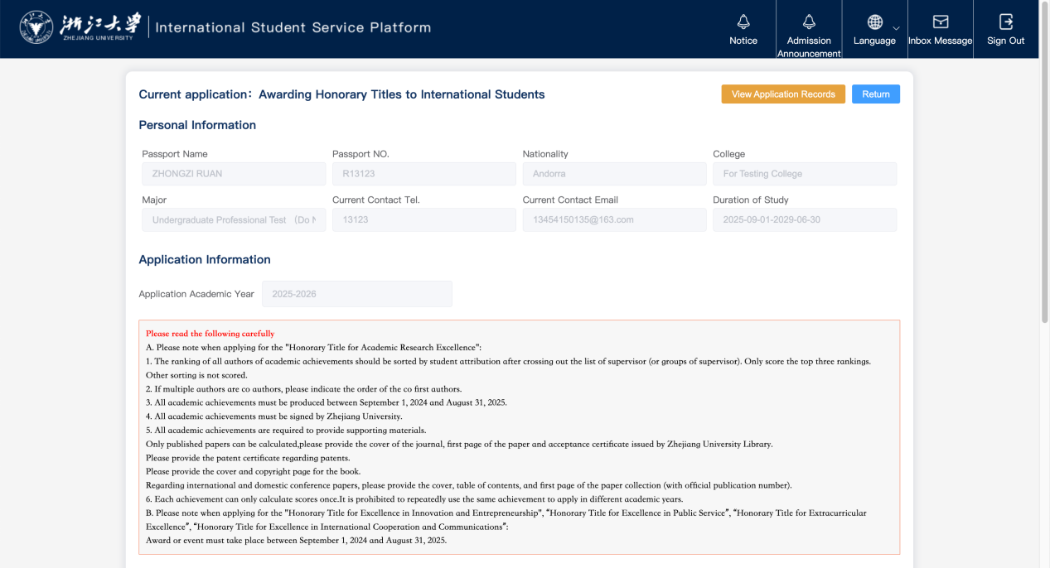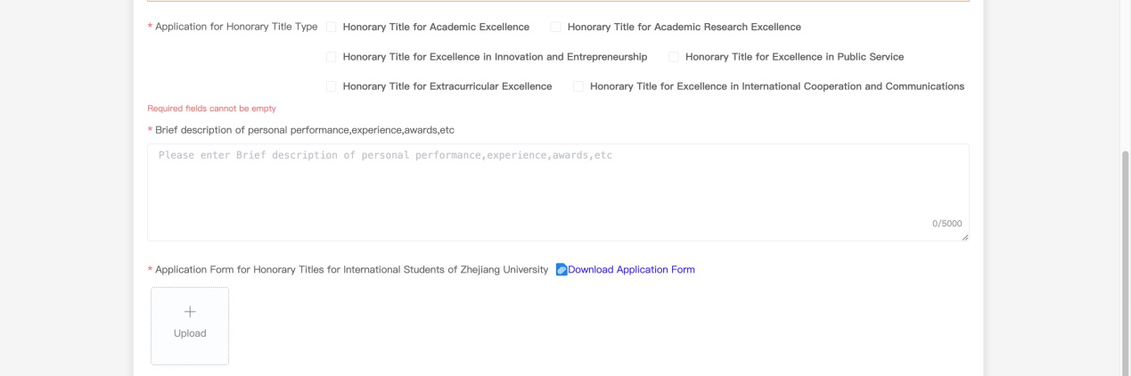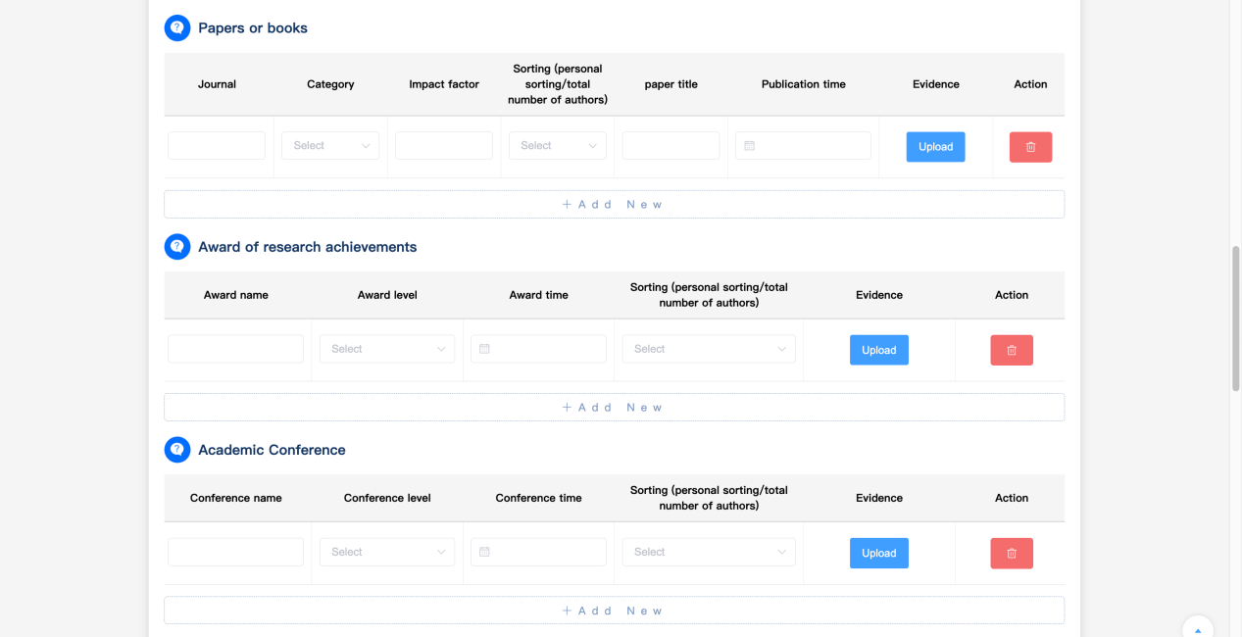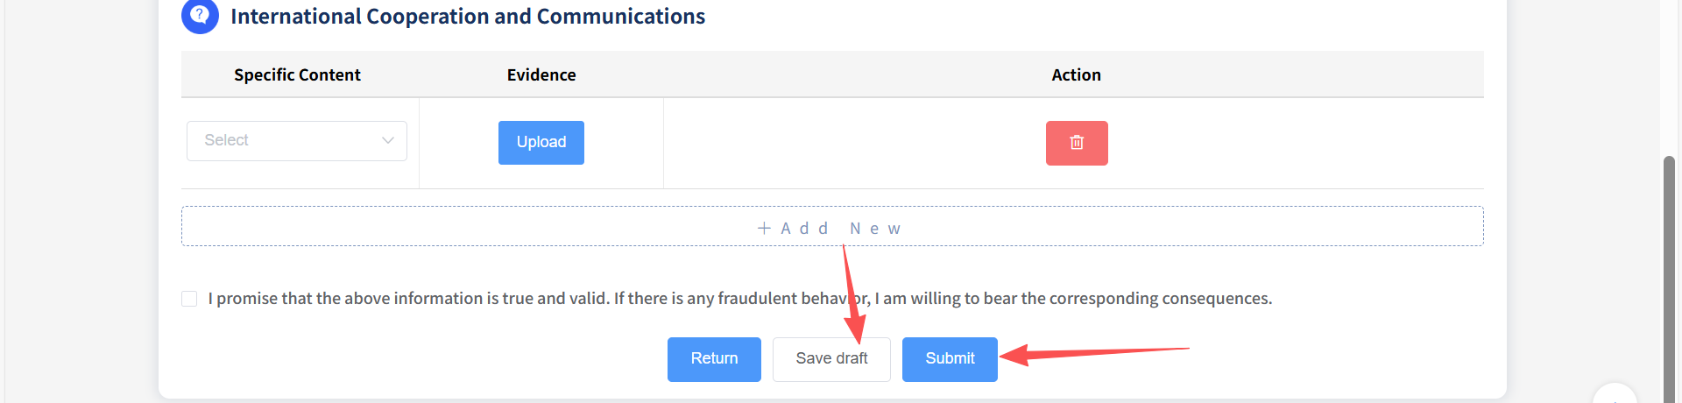
  - 查看申请记录：点击【查看申请记录】，即可查看
View Application Records: Click on "View Application Records" .
