  - 浏览器中输入 https://intlstudent.zju.edu.cn/isstu，点击统一身份认证登录系统（建议使用谷歌浏览器）
Enter https://intlstudent.zju.edu.cn/isstu in your browser and click the Unified Identity Authentication to log in to the system (Google Chrome is recommended).
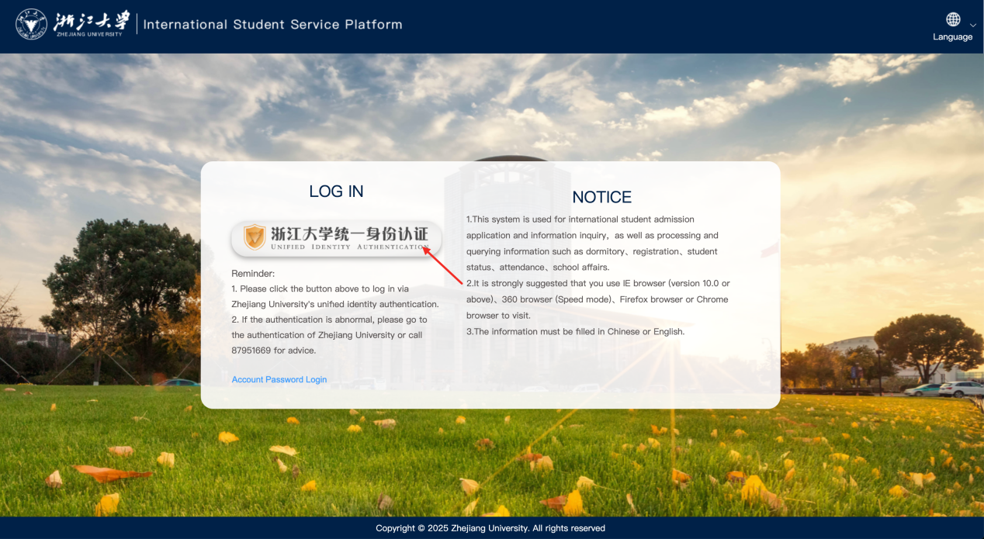
  - 进入系统后点击“评奖评优”
After entering the system, click on "Award for Excellence".
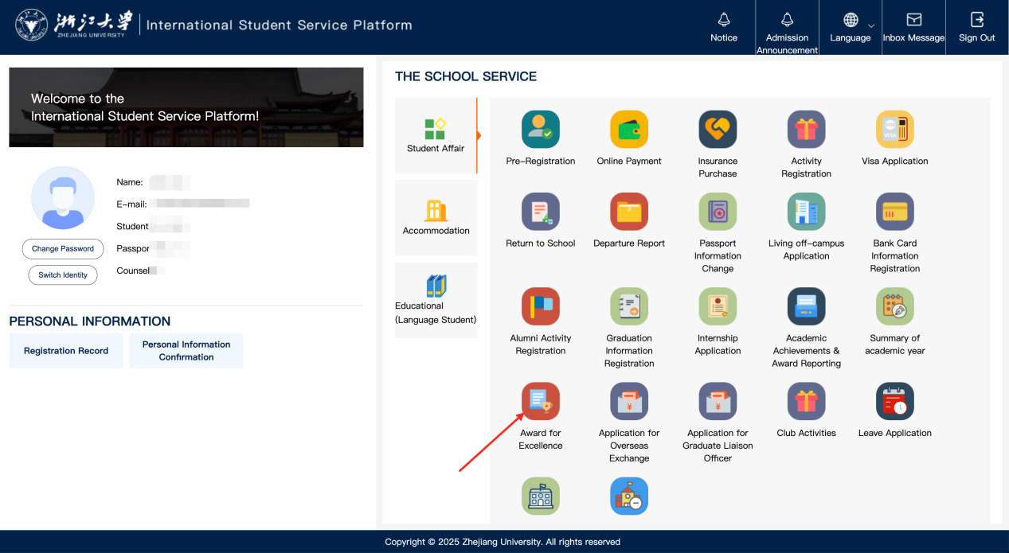
  - 选择“浙江省政府奖学金”
Click “Zhejiang Government Scholarship”.
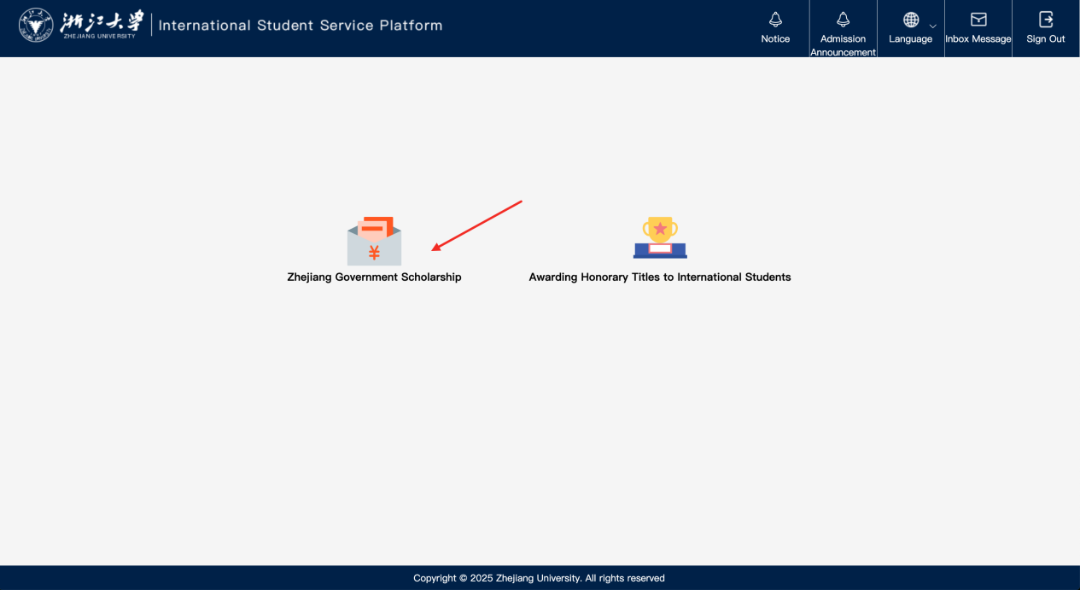
  - 根据页面提示确认个人信息、阅读申请须知并填写申请信息，点击“保存草稿”后，点击“申请表下载”，签字盖章后将申请表上传，点击提交，即可完成。
Follow the on-screen prompts to check your personal information, read the application guidelines, and complete the application form. Click “Save Draft”, select “Download Application Form”. After signing and stamping the form, upload the form. Click “Submit” to complete the process.
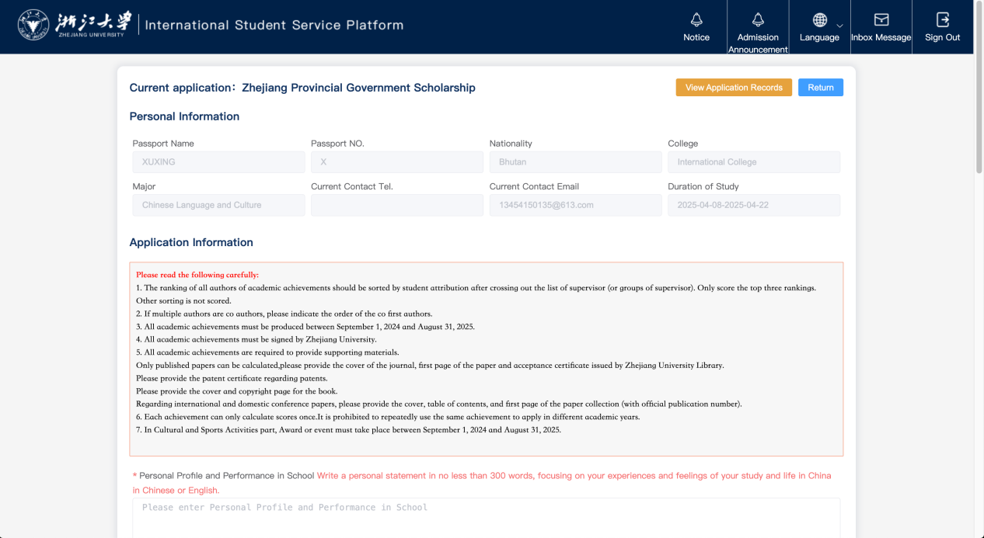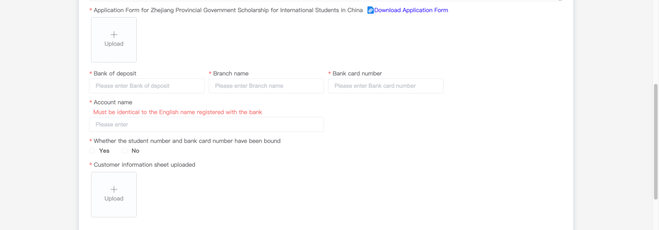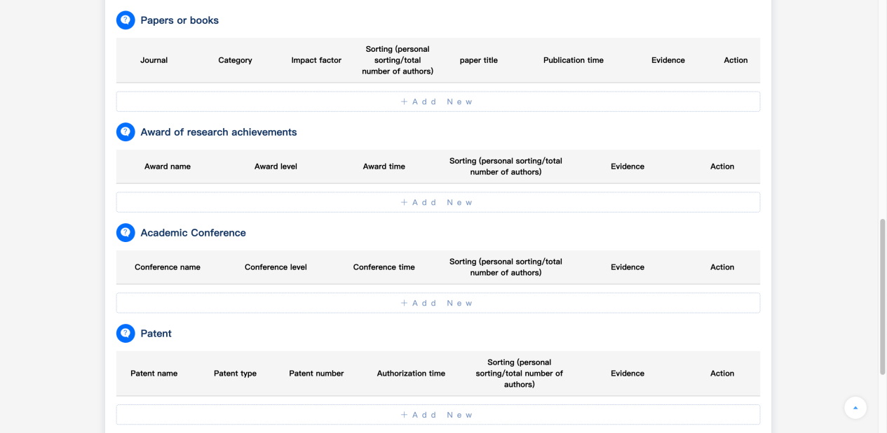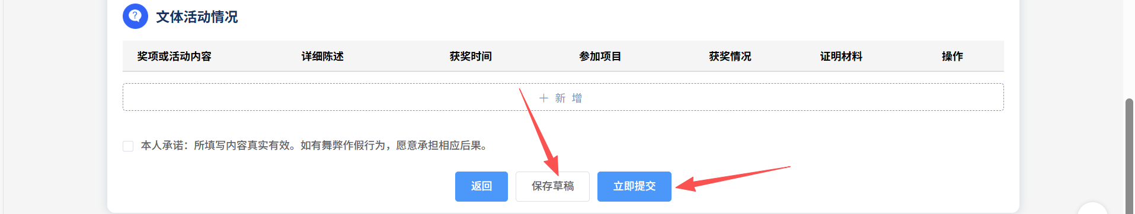
  - 查看申请记录：点击【查看申请记录】，即可查看
View Application Records: Click on "View Application Records".
